**Name: Jesnamol Thomas**

**Roll No: 6**

**Batch: B**

**Date: 01/03/22**

**NETWORKING & SYSTEM ADMINISTRATION LAB**

**Experiment No.: 2**

**Aim**

Familiarization of linux command.

**Procedure**

**17. cat –n filename :** To display line number.

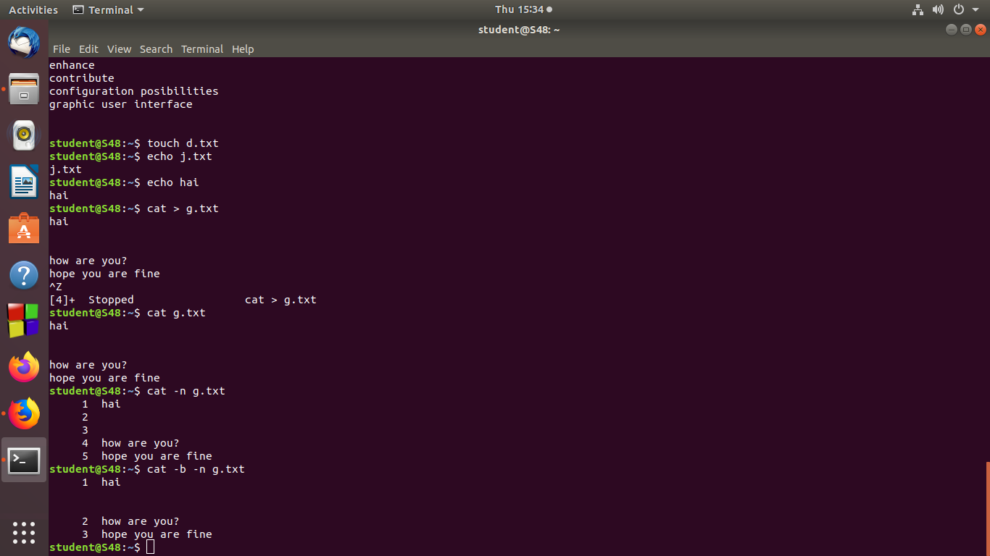

**18. cat –b filename :** To remove empty lines.



**19. touch filename :** To create a new blank file.

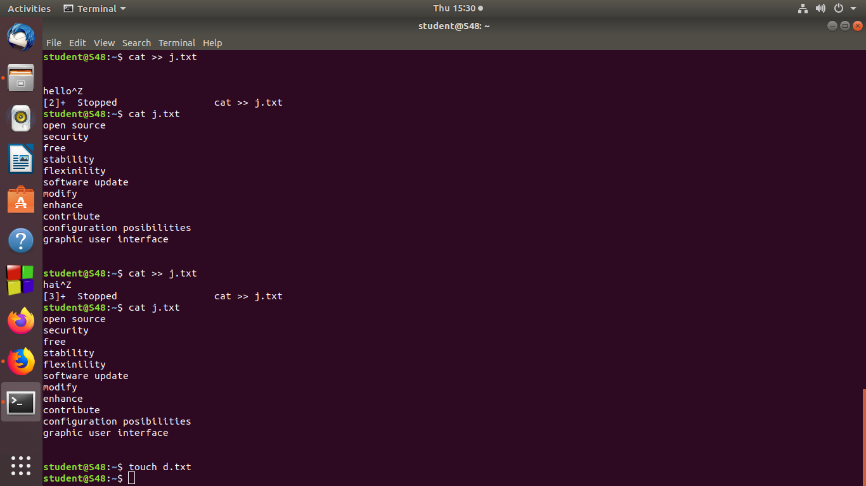

**20. echo “ ” >> filename :** To append data from a command to the end of a text file.

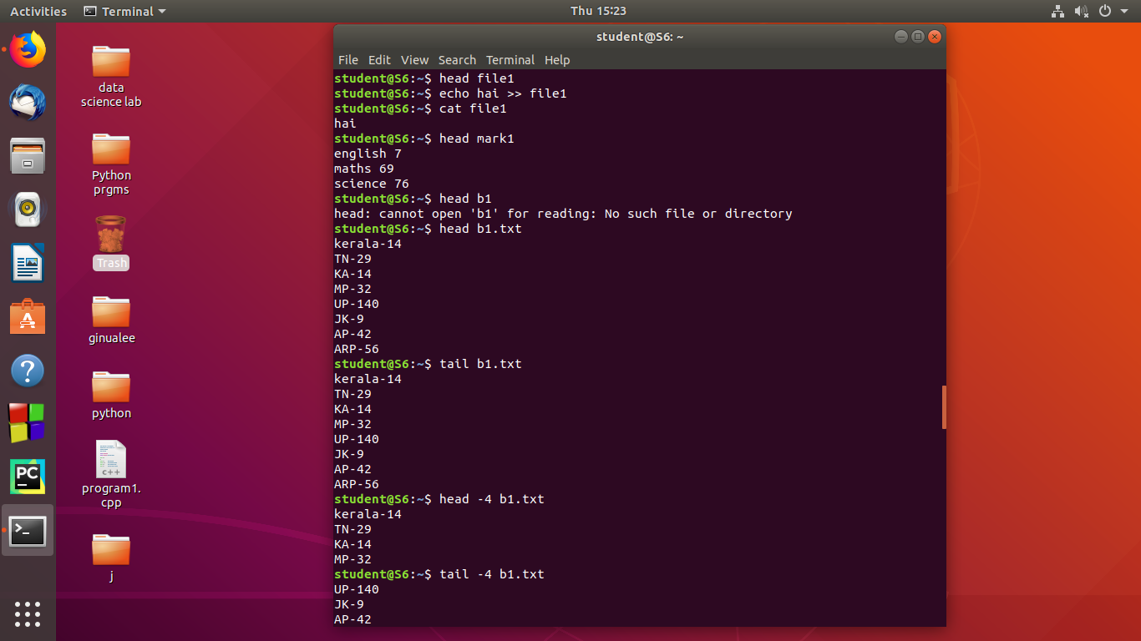

**21. head filename :** To display first ten lines of specified file.



**22. head -n filename :** Todisplay first specified number of lines instead of ten lines.

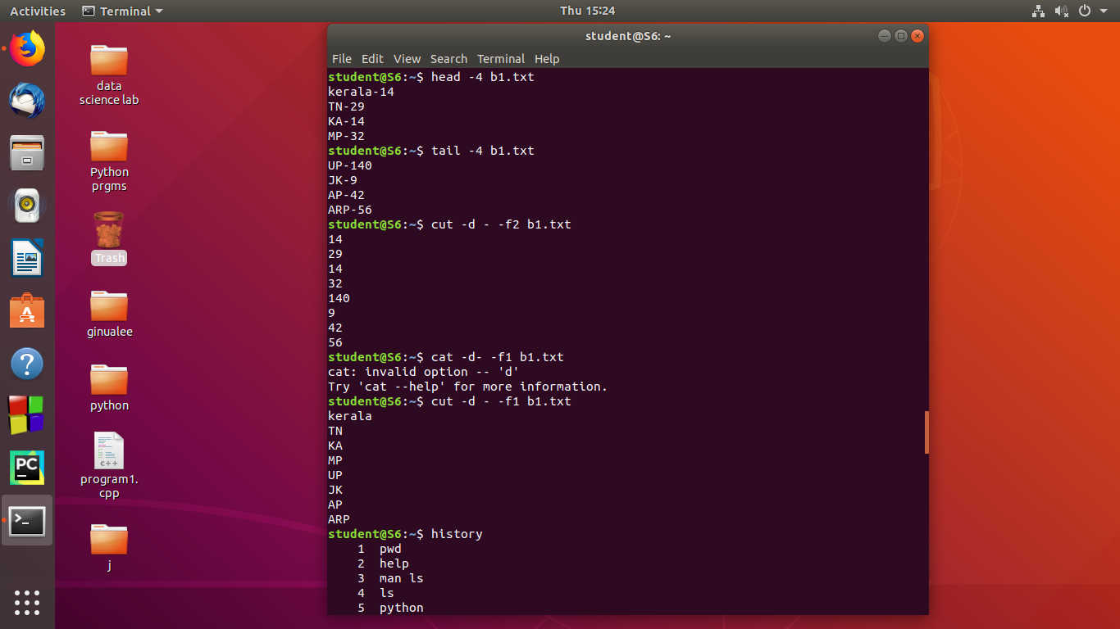

**23. tail filename :** To display last ten lines of specified file.



**24. tail -n filename :** Todisplay last specified number of lines instead of ten lines.



**25. cut -b 2 filename: Display the second character of line.**

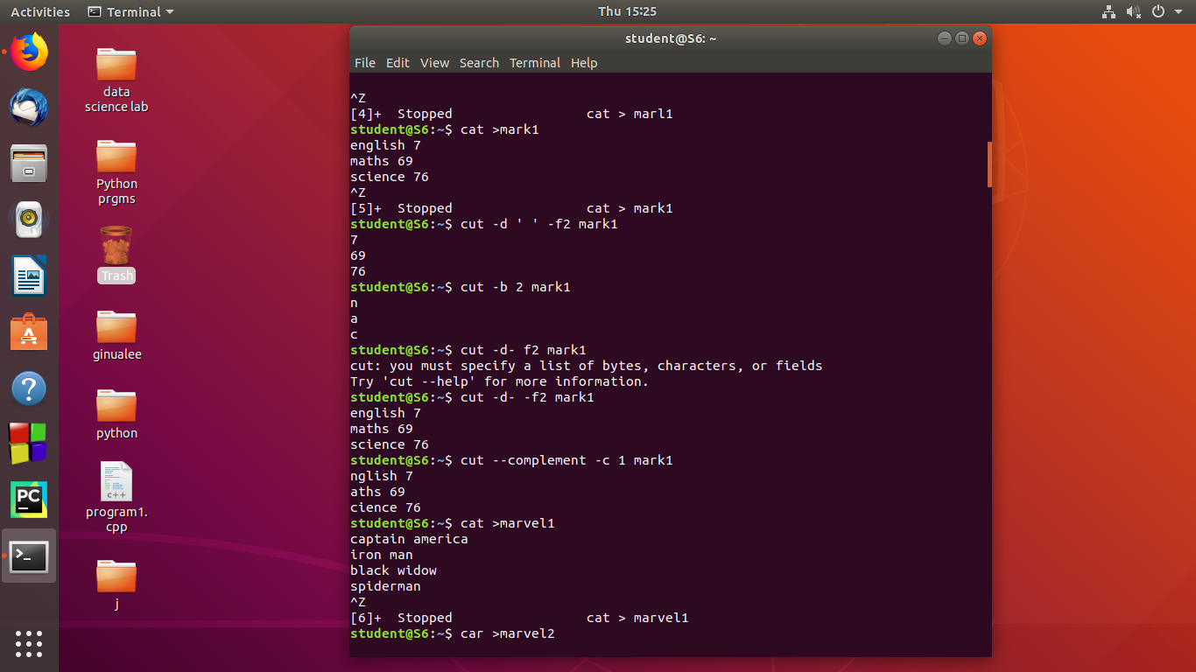

**26. cut –complement -c 1 filename :** Remove first character.



**27. paste file1 file2 :** It is used to join file horizontally by outputting lines consisting of lines from each files specifies ,separated by tab as delimiter to the standard output.

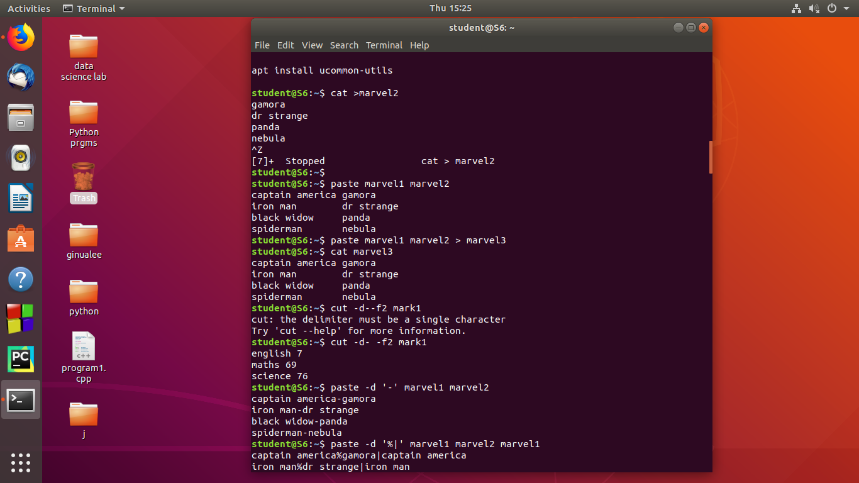

**28. paste file1 file2 > file3 :** It is used create file3 and paste the contents from file1 and file2.



**29. paste -d ‘-‘ file1 file2 :** Used the ‘-’delimiter for merging the file.



**30. paste –s file1 file2 :**To merge the files in sequentially manner using the –s option.

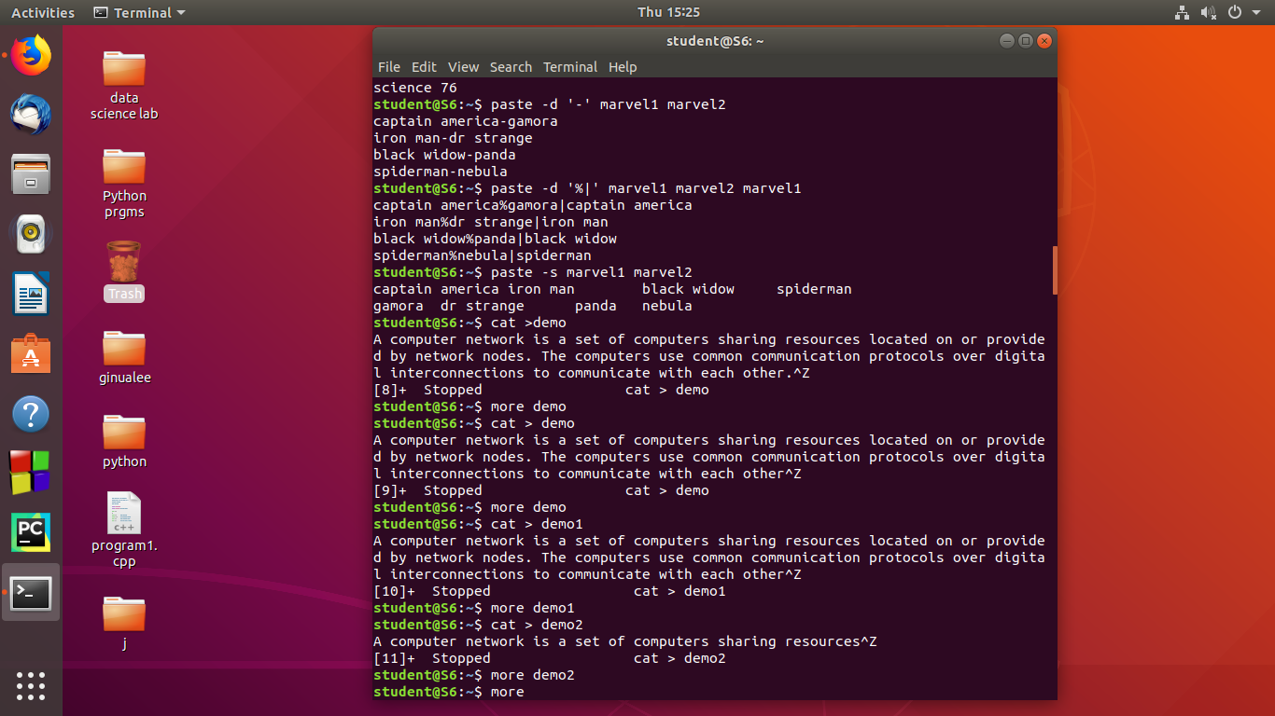

**31. paste –d ‘%d|’ :** First and second file is separated by ‘%’ and second and third is separated by ‘|’ after that list is exhausted and reduced.



**32. more filename :** It is used to view the text files in the command prompt,displaying one screen at a time in case the file is large.

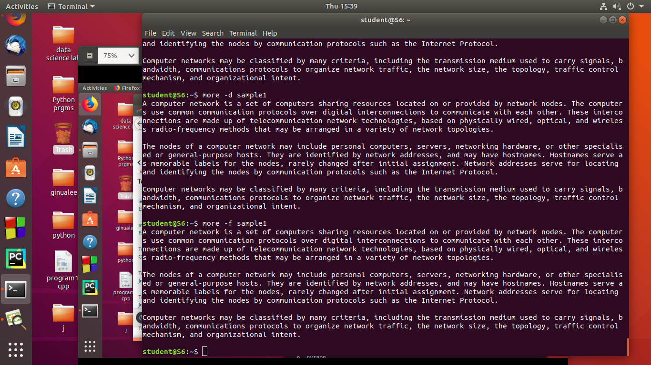

**33.more –s filename :**

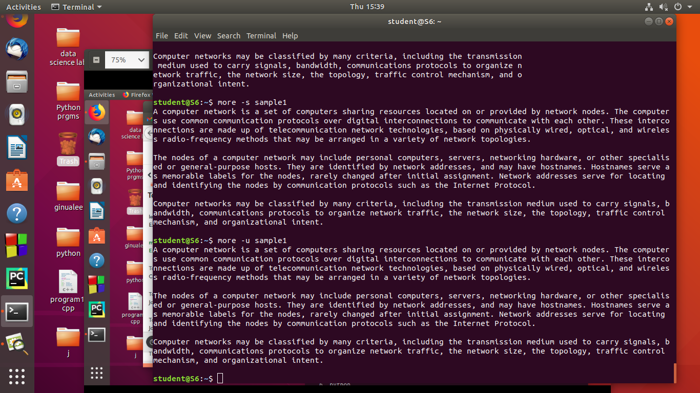

**Output Screenshot**